Soil erosion detection

Internship test

by Maksym Maiboroda

Date: 14-07-2021

**Preparation of geodata for further analysis**

The first steps were aimed at working with geodata such as .jp2 and .shp. and converting this data into a more familiar format

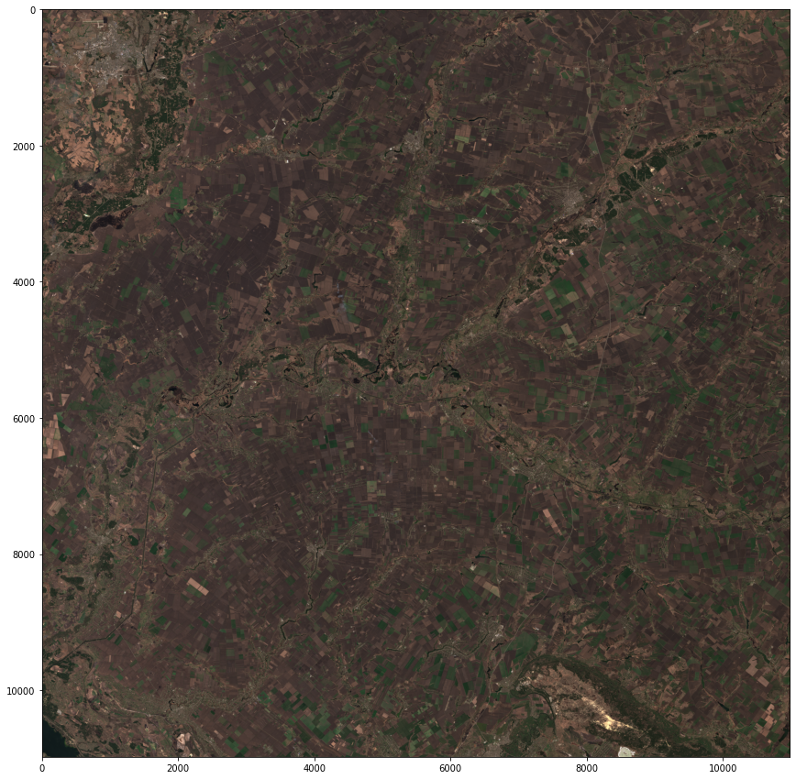

Fig. 1 Map image

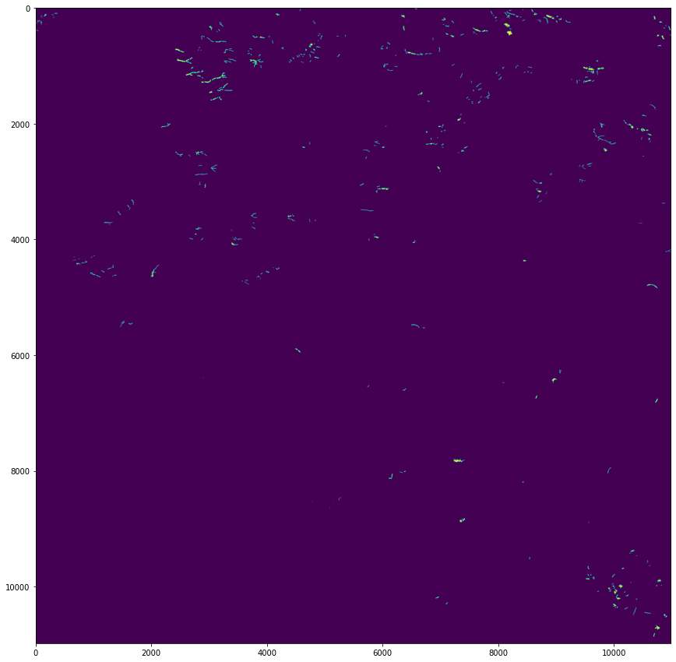

Fig. 2 Binary mask image.

Overlaid two images saw not all erosion zones are marked on the mask.

Therefore, it was decided to use a neural network on the Unet architecture which has good resistance to missing data.

For training, the input image and mask were split into small 256x256 pixel tiles

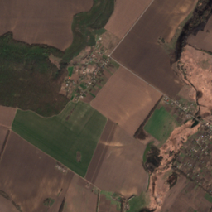

Fig. 3 example of map and binary mask tile

**Results**

It is difficult to assess the quality of the resulting model, due to its complexity and limited time.

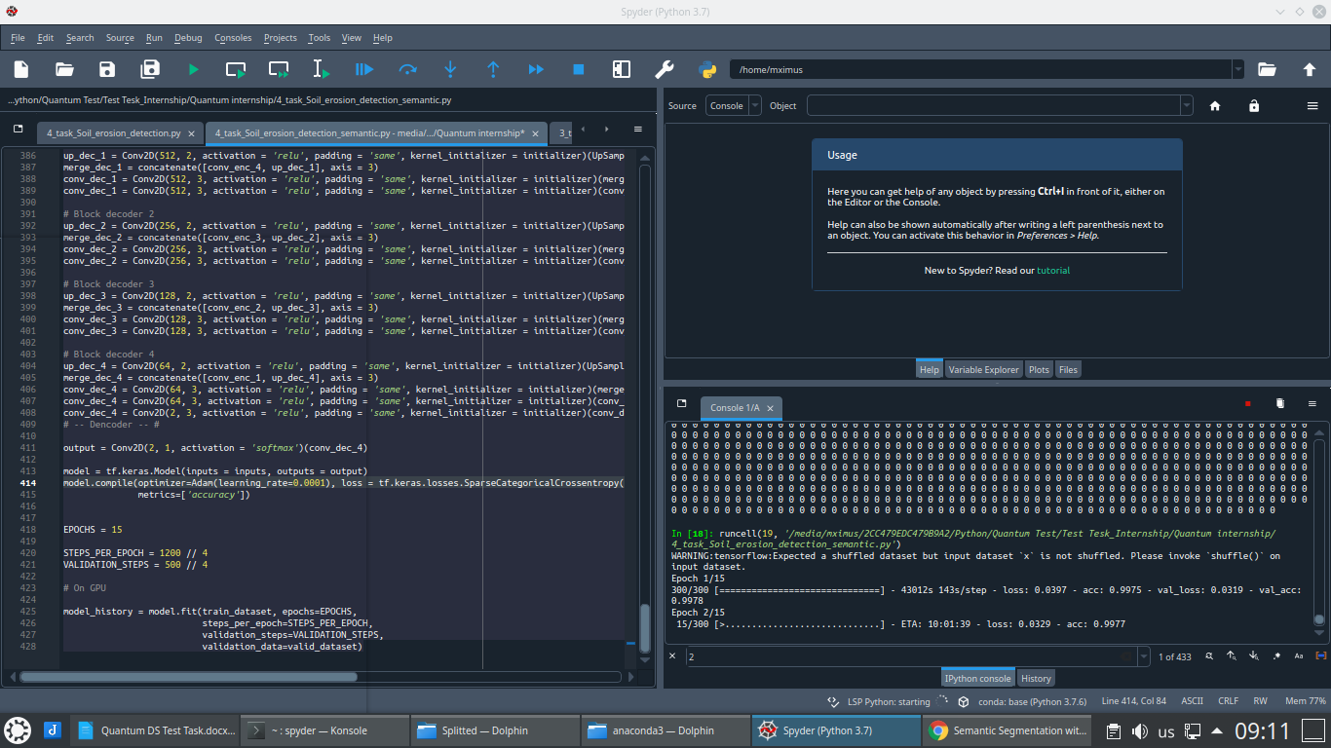

Transfer to google collab also did not allow to speed up the work, due to its slow processing of a large number of small images.

[Dataset link](https://drive.google.com/drive/folders/1JFfGkDo7monMkMrvtiaWGwS9SMkfjUy0?usp=sharing)